\*\*this’s (top-left) a DEFAULT constructor (this sets all variables to zero) 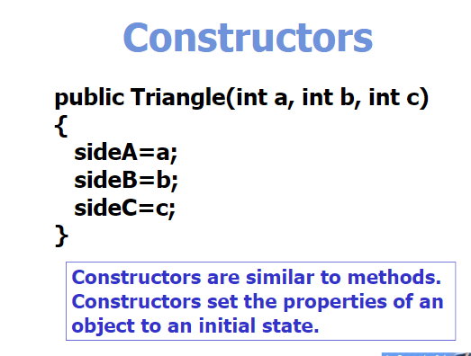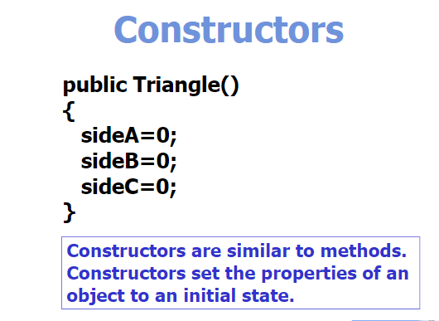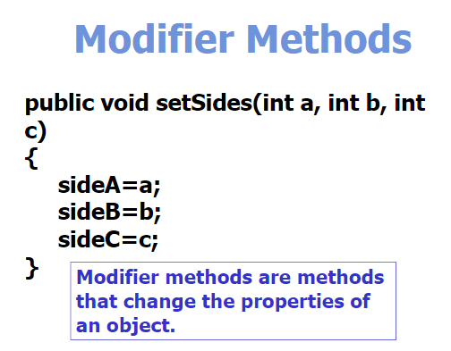

\*\*You can call the modifier method inside the constructor to increase ‘efficiency’

\*\*Accessor method: public String toString(){}

\*\*CONSTRUCTOR OVERLOADING occurs when you have multiple constructors so Java knows which one to use depending on the inputted arguments (no two constructors can have the same order of parameters)